

**Philadelphia University Faculty of Information Technology**

**Final year project 1 Department of Software Engineering**

Human Resource Management System.

**Supervisor:** Dr. Mohammad Taye.

**Students Name**: Fahed Khalil

Wesam Da’abes

Malik Qawasmeh

**Table of Contents:**

**CH1: Proposal**

**1.1 Goals and Objectives**

**....................................................................................................................................... 5**

**1.2 Brief description of the project**

**....................................................................................................................................... 5**

**1.3 References**

**....................................................................................................................................... 5**

**1.4 Prerequisite**

**....................................................................................................................................... 6**

**1.5 Project Specialization**

**....................................................................................................................................... 6**

**1.6 Title**

**....................................................................................................................................... 6**

**1.7 Introduction**

**....................................................................................................................................... 6**

**1.8 Objective**

**....................................................................................................................................... 6**

**1.9 Problem Statement**

**....................................................................................................................................... 6**

**1.10 Motivation**

**....................................................................................................................................... 7**

**1.11 Literature Review**

**....................................................................................................................................... 7**

**CH2: Requirement Engineering Part**

**2.1 Domain Understanding**

**....................................................................................................................................... 9**

**2.1.1 Context**

**....................................................................................................................................... 9**

**2.1.2 Scope of the systems as-is**

**....................................................................................................................................... 9**

**2.1.3 Stakeholders**

**....................................................................................................................................... 9**

**2.1.4 Strengths and Weaknesses of the system as-is**

**....................................................................................................................................... 9**

**2.1.5 Glossary of Terms**

**....................................................................................................................................... 9**

**2.2 Requirement Elicitation**

**....................................................................................................................................... 9**

**2.2.1 Requirement Specification**

**....................................................................................................................................... 13**

**2.2.2 Requirements Analysis**

**....................................................................................................................................... 15**

**2.2.3 Requirements Validation**

**....................................................................................................................................... 15**

**2.2.4 Requirement Modeling**

**....................................................................................................................................... 16**

**CH3: Software Requirements Specification**

**3.1 Introduction**

**....................................................................................................................................... 18**

**3.1.1 Purpose**

**....................................................................................................................................... 18**

**3.1.2 Scope**

**....................................................................................................................................... 18**

**3.1.3 Definitions, acronyms and abbreviations**

**....................................................................................................................................... 19**

**3.1.4 References**

**....................................................................................................................................... 19**

**3.2 Overview**

**....................................................................................................................................... 19**

**3.2.1 Overall description**

**....................................................................................................................................... 20**

**3.2.2 User characteristics**

**....................................................................................................................................... 20**

**3.2.3 Product prespictive**

**....................................................................................................................................... 21**

**3.2.4 Product functions**

**.................................................................................................................................... 22**

**3.2.5 Constraints**

**....................................................................................................................................... 22**

**3.2.6 Assumptions and dependencies**

**....................................................................................................................................... 22**

**3.2.7 Apportioning of requirements**

**....................................................................................................................................... 22**

**3.3 Functional Requirements**

**....................................................................................................................................... 22**

**3.4 Non- Functional Requirements**

**....................................................................................................................................... 26**

**3.5 User interfaces**

**....................................................................................................................................... 27**

**3.5.1 Software interface**

**....................................................................................................................................... 32**

**3.5.2 Communication interface**

**....................................................................................................................................... 32**

**3.6 Software system attributes**

**....................................................................................................................................... 33**

**CH4: Software Architecture**

**4.1 Introduction**

**....................................................................................................................................... 33**

**4.2 Benefits Of Software Architecture**

**....................................................................................................................................... 34**

**4.3 Importance Of Software Architecture**

**....................................................................................................................................... 34**

**4.4 Selected technology**

**....................................................................................................................................... 35**

**Chapter 1: Proposal**

**1.1 Goals and Objectives**

1) Usability and efficiency of employees services

2) Generate reports of employee leaves or vacation and complaints

3) To calculate the employee salary

**1.2 Brief description of the project**

The HR Management system is one of the most important systems that must be available in every company because it will save time and effort to complete some simple transactions. Job description is the completion of some transactions online, the most important of which is (requesting a vacation, submitting a complaint to the manager or knowing the employee’s daily working schedule, through which or Inquire about the date of receiving the salary and its value. And each employee can registration with employee id and password.

**1.3 References** **:1)**

**IEEE Citation Style Guide**

**World Wide Web**

A.projects*. “Title.” Web student portal for the it and management : www.freeprojectz.com, Nov.7,2014* [March.10,3,2021].

**Lecture**

M. Tayee. Dr. final project, Topic: “discussing.” ICT 224, Faculty of IT, University of Philadelphia, Jordan, Amman, April. 31, 2021.

**E-mail**

W.daabes “new message ,done?wesamdaabes98@gmail.com ”. (April.3,2021).

**Project Requirements (Hardware & Software)**

.**-**

**Company** **or organization (If applicable)**   
not applicable

**1.4 Prerequisite**   
 Completion of 90 study hours

**1.5 Project Specialization (Software Engineering)**Software Engineering

**1.6 Title** **:** HR Management system

**1.7 Introduction:**

The proposed project "HR Management System" has been developed to overcome the problems faced in the practicing of manual system. This software is built to eliminate and in some cases reduce the hardships faced by the existing system. Moreover this system is designed for particular need of the company to carry out its operations in a smooth and effective manner.

It is a special system for employees in any company in which basic jobs are available for any employee, such as (vacations - working hours - employee or manager notes within work - and salary inquiries).

**1.8 Objective:**

1) Useability and efficiency of employees services.

2) Generate reports of employee leaves or vacation and complaints.

3) To calculate the employee salary.

**1.9 Problem Statement:**

Overcoming the problems facing the manual system and creating transactions electronically to make it easier for employees and management to communicate between them .

**1.10 Motivation:**

The motivation of the project is to provide employee services in a simple and fair way for business operations to run smoothly. Leave requests management also handle staffing requirements with ongoing policy and legal compliance.

**1.11 Literature Review:**

**sagar informatics**

### HR software to retain and develop employees, drive engagement, optimize benefits, and increase productivity.

sagar Informatics is HR software that features a record of assigned tasks, employee data analysis, employee monitoring, a centralized employee database, worksheet and timesheet management, and time-off tracking.

This software has a good track record of after-sales support and other customer service resources. Issues are dealt with promptly by email or phone and they have multiple numbers at which they can be reached.

### Sap SuccessFactors

### HR software to retain and develop employees, drive engagement, optimize benefits, and increase productivity.

### Sap SuccessFactor is an engagement-focus HR tool that offers flexible employee surveys, role-based dashboards and reporting, customizable impact reports, event-based triggers, and employee rewards programs.

**Methodology:**

Waterfall model because requirement are very well known , product definition is stable

Technology is understood . easy to use , quality is more important than cost or schedule .

**Chapter 2: Requirement Engineering Part**

**Requirement Engineering Part:**

**2.1 Domain Understanding:**

HR Management System is a website used to complete some simple transactions using the Internet instead of the paper-based system. The site provides the following services: 1) Request leave or submit a complaint to the manager 2) The daily work schedule in addition to the number of additional hours desired by the employee 3) Inquire about the salary and its value this month 4) Each employee can register with the employee's identification number and password.

**2.1.1 Context:**

The system as is takes place of paper based system and it’s objectives. But the website saves Time, Effort and Useability .

**2.1.2 Scope of the systems as-is:**

This project is beneficial for companies in maintaining employee record. Salary calculation for each employee and also focus on attendance of each employee and the number of leaves taken per month / year. There is also the possibility to check the salary report at any time so as not to lead to any miscalculation.

* + 1. **Stakeholders:**

|  |  |
| --- | --- |
| Actor | Interests |
| Managing Director | Salary, Working hours, Job security,  Managing vacation request and reports. |
| Employees | Salary, Working hours, Job security, Vacation request or reports. |
| Company Owners | Business operations to run smoothly, Profit. |
| IT Developer | Create the website, Level of security, Privacy, Data Storage. |

**2.1.4 Strengths and Weaknesses of the system as-is**

The Strength Of Paper System Is :

Documentation.

The Weaknesses Of Paper System Is :

1. Prone to damage: Manual documents can be easily damaged, lost, or stolen.
2. Higher costs: Because we will need more paper, printers, copiers, stationery and other office supplies.
3. Lack of security: Paper is one of the biggest information security risks for companies because printed documents can easily be lost, mishandled, or destroyed while digital data can be encrypted and kept securely in hard disks or electronic devices.
   * 1. **Glossary of Terms:**

|  |  |  |
| --- | --- | --- |
| **1** | EIN | Employee Identification Number |
| **2** | HRMS | Human Resource Management System |
| **3** | LMS | Leave Management System |
| **4** | OP | Overtime Pay |

**2.2 Requirement Elicitation**

*1.*  **Retained Requirement elicitation techniques**

**-** *Which ones?* Questionnaire

*- Motivations?* we can't meet the employee in this time cause of corona virus

For easy access to a larger number of employees and for accurate reports and Asking the employee easily than making and save time also

*2.* **Requirement Elicitations Documents**

**Questionnaire about HR management system**

**Employee information**

|  |  |
| --- | --- |
| Employee id : | Name : |
| Employee job title : | Department : |

**Please encircle only one number from 1-6 that indicates your disagreement or agreement according to your experience and impression about HR management information.**

|  |  |  |  |  |  |  |
| --- | --- | --- | --- | --- | --- | --- |
| **Very Strongly Agree** | **Strongly Agree** | **Agree** | **Disagree** | **strongly Disagree** | **Very Strongly Disagree** |  |
|  |  |  |  |  |  | Employees are regularly informed about the initiatives taken by the HR department |
|  |  |  |  |  |  | In this system , it is clear what belongs to the tasks and what’s outside the field of the HR management information |
|  |  |  |  |  |  | In this system, HR procedures are easy to follow |
|  |  |  |  |  |  | Employees fully understand how HR practice works in the system |
|  |  |  |  |  |  | Top managers believe that HR is the key for development of the institution |
|  |  |  |  |  |  | In general, the HR staff is met with much appreciation in this organization |

Does every employee have enough vacation days ?

Does HR saves time and effort ?

Are manual issues already eliminated in this HR system?

Do you recommended this HR system ?

Do you have privileges?

Please choose one of the following (Agree, disagree, neither agree or disagree)

|  |  |  |  |
| --- | --- | --- | --- |
| Neither agree or disagree | Disagree | Agree |  |
|  |  |  | Organization’s HR executives are fully aware of the business needs and strategies |
|  |  |  | Efforts are taken to generate awareness amongst the employees about the organization’s financial position, customers’ needs, quality of product/service, cost etc |
|  |  |  | The organization’s human resource requirements are systematically ascertained and an appropriate plan is formulated for satisfying the requirements |
|  |  |  | The organization has a formal policy of career planning and development |
|  |  |  | There are distinct career paths and internal promotion norms within the organization |

**2.2.1 Requirement Specifications**

**2.2 Software Requirements**

**2.2.1 Functional Requirements**

**Admin:**

|  |  |
| --- | --- |
| Functional | Description |
| Login | Log in using the administrator number and password |
| Change password | The password change or restore |
| Add new employee | The Admin can add a new employee |
| Add attendance dates for employees | The Admin can add working time for employees |
| Accept or reject holiday or leave | The Admin can approve or deny a holidays or leave To the employee with the reason written |
| Calculate the salary | The Admin can Calculate the salary To the employee |
| view employee review | The Admin can view and respond to employee feedback |

**Employee:**

|  |  |
| --- | --- |
| Functional | Description |
| login | Log in using the employee number and password |
| Change password | The password change or restore |
| Request holiday or leave | Employees are allowed to request holiday or leave |
| Writ a complaint or a note to the director | Employees are allowed to submit a complaint or note to the manager |
| view work time | Employees are allowed to view working hours |
| view the salary | Employees are allowed to view the salary amount |
| Admin reviews | It allows employees to view the manager's notes |

**Non Functional Requirements**

Usability: the system is easy to use by the users, we tried to provide easy control interfaces in the design.

**2.2.2 Requirements Analysis**

The requirement was read and it was clear and understandable and there is no ambiguity in it and it was easy to apply and it was dealt together with all transparency

**2.2.3 Requirements Validation**

|  |  |  |  |
| --- | --- | --- | --- |
|  | **Question** | **Yes** | **No** |
| **1** | Does it possible to implement all of the requirements? | Yes |  |
| **2** | Is the maintainability of the system/software specified?  Including the ability to respond to changes in the operating environment, interfaces, accuracy, performance, and additional predicted capabilities. |  | No |
| **3** | Have requirements for communication among system/software components been specified? | Yes |  |
| **4** | Have overall function and behavior of the system/software been defined? | Yes |  |
| **5** | Is the maximum memory specified? |  | No |
| **6** | Do the requirements define all the information that is to be displayed to the user? | Yes |  |
| **7** | Are there conflicting requirement? |  | No |
| **8** | Is each requirement testable? | Yes |  |
| **9** | Is the level of security specified? | Yes |  |
| **10** | Have the software and hardware environments been defined? | Yes |  |
| **11** | Are the specified error messages unique and meaningful? | Yes |  |
| **12** | Is each requirement in scope for the project? | Yes |  |

**2.2.4 Requirement Modeling:**

**Use case:**

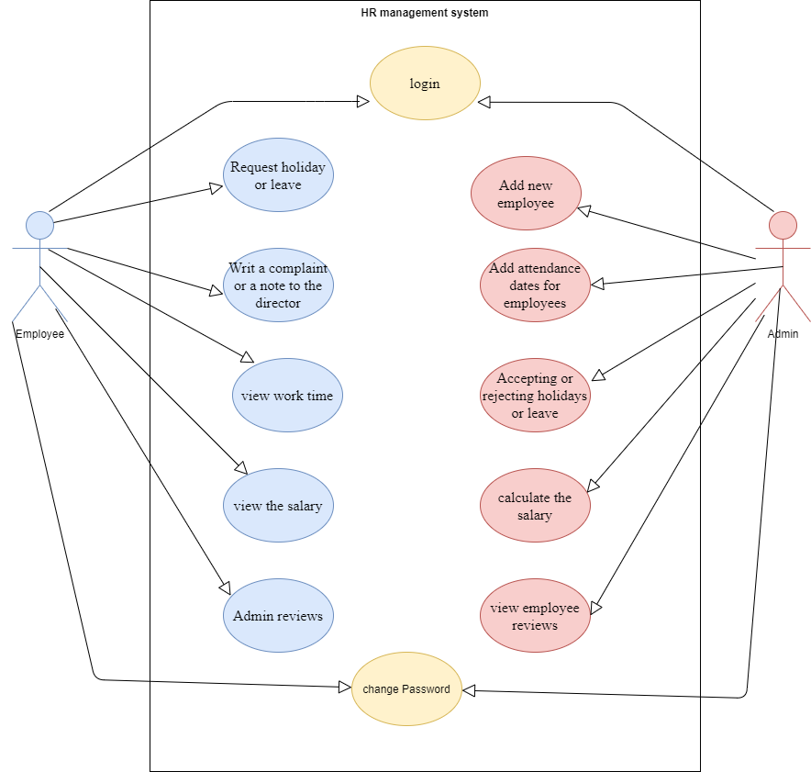

**Figure(1): Use case**

**Class diagram:**

Here will see the class diagram for the HRMS in figure (2). That illustrate a system’s structure in

a detailed way ,showing its attributes ,operations as well as its relations.

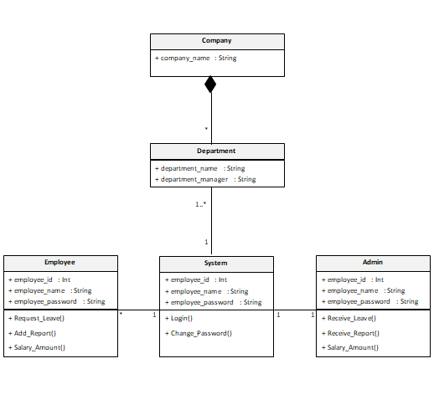

**Figure(2): Class Diagram**

**Chapter 3:Software Requirements Specification**

**3.1 Introduction:**

This document is a Software Requirement Specification (SRS) for the Human Resources Management System (HRMS) Project. We will give a complete description for overview and list the requirements which meet the needs of the company.

**3.1.1 Purpose:**

The purpose of this document is to give a detailed description of the requirements of HR Management System (HRMS). This document is primarily intended to be proposed to overcome the problems faced in the practicing of manual system, reduce the hardships faced by the existing system and to particular need of the company to carry out its operations in a smooth and effective manner.

**3.1.2 Scope:**

HR Management System is a website used to complete some simple transactions using the Internet instead of the paper-based system. The site provides the following services: 1) Request leave or submit a complaint to the manager 2) The daily work schedule in addition to the number of additional hours desired by the employee 3) Inquire about the salary and its value this month 4) Each employee can register with the employee's identification number and password.

This website is beneficial for companies in maintaining employee record. Salary calculation for each employee and also focus on attendance of each employee and the number of leaves taken per month / year. There is also the possibility to check the salary report at any time so as not to lead to any miscalculation.

**3.1.3 Definitions, acronyms and abbreviations:**

|  |  |  |
| --- | --- | --- |
| **1** | SRS | Software Requirements Specification |
| **2** | EIN | Employee Identification Number |
| **3** | HRMS | Human Resource Management System |
| **4** | LMS | Leave Management System |
| **5** | OP | Overtime Pay |
| **6** | Admin / Administrator | Administrator who is given specific permission for managing and  controlling the system |

**3.1.4 References**

**IEEE Citation Style Guide**

**World Wide Web**

A.projects*. “Title.” Web student portal for the it and management: www.freeprojectz.com, Nov.7,2014* [March.10,3,2021].

**Lecture**

M. Tayee. Dr. final project, Topic: “discussing.” ICT 224, Faculty of IT, University of Philadelphia, Jordan, Amman, April. 31, 2021.

**E-mail**

W.daabes “new message ,done?wesamdaabes98@gmail.com ”. (April.3,2021).

**3.2 Overview:**

The remainder of this document includes three chapters and appendixes. The second one provides an overview of the system functionality and system interaction with other systems. This chapter also introduces different types of stakeholders and their interaction with the system. Further, the chapter also mentions the system constraints and assumptions about the product.

The third chapter provides the requirements specification in detailed terms and a description of the different system interfaces. Different specification techniques are used in order to specify the requirements more precisely for different audiences.

The fourth chapter deals with the prioritization of the requirements. It includes a motivation for the chosen prioritization methods and discusses why other alternatives were not chosen. The Appendixes in the end of the document include the all results of the requirement prioritization and a release plan based on them.

**3.2.1 Overall description:**

This section will give an overview of the whole system. The system will be explained in its context to show how the system interacts with other systems and introduce the basic functionality of it. It will also describe what type of stakeholders that will use the system and what functionality is available for each type.

At last, the constraints and assumptions for the system will be presented.

This section does not state specific requirements. Instead it provides a back ground for those requirements, which are defined in section 3, and makes them easier to understand.

**3.2.2 User characteristics:**

There are three types of users that interact with HRMS: Employees, Managing Director/Admin and Company Owners . Each of these three types of users has different use of the system so each of them has their own requirements.

Employees: The website provides the following services for employees: 1) Request leave or submit a complaint/report to the manager 2) The daily work schedule in addition to the number of additional hours desired by the employee 3) Inquire about the salary and its value with OP working this month 4) Each employee can register with the EIN and password.

Managing Director/Admin: Manager is also an employee and his interests in the website will be: Salary, Working hours, Job security. But he has a special validity which is managing vacation request and reports. Which is mean he can accept or reject the vacation request or reports.

Company Owners: The only thing that company owners are interested in the website is profit and business operations to run smoothly.

**3.3.3 Product perspective:**

This system consists of a website. The website will be used to facilitate the process of information exchange between the two parties of the manager and the employee and the completion of transactions for the employees.

The website will need to connect to the internet from any smart device in order to be able to use it. The website will provide the employee with jobs like (vacations - working hours - employee or manager notes within work - and salary inquiries)

The functions provided by the website will be included so that the user can use the functions in the application smoothly Since this is a data-driven product, it will need somewhere to store the data. Therefore, a database will be used. The website will communicate with the database.

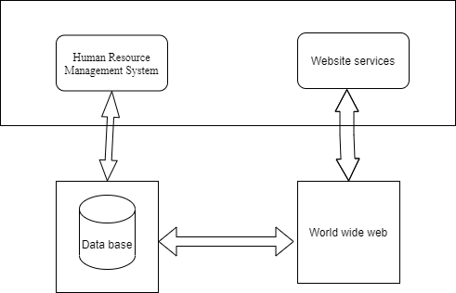

**Figure(1): Product perspective:**

**3.2.4 Product functions:**

Completing some online transactions, the most important of which are (requesting leave, submitting a complaint, sending notes to the manager or receiving them, knowing the employee's daily work schedule or from or calculating the employee's salary.

**3.2.5 Constraints:**

Internet connection is also restricted on the website. Since the website fetches data from the database over the internet, it is vital that there is an internet connection for the website to function.

**3.2.6 Assumptions and dependencies:**

One of the assumptions about the product is that it will always be used on the website accessed from any smart device. For example, users may have customized it with other websites, there may be scenarios where the website does not function as intended or even at all.

**3.2.7 Apportioning of requirements:**

In the case that the project is delayed, there are some requirements that could be transferred to the next version of the website.

**3.3 Functional requirements:**

This section includes the requirements that specify all the main actions of the software system.

**Functional Requirement 1**

**TITLE:** log in

**DESC:** The user must be able to enter the site and choose the employee or manager **RAT**: for the user to use the website

**DEP:** FR1.

**Functional Requirement 2**

**TITLE**:  change Password

**DESC**: The password change or restore

**RAT**: To maintain privacy

**DEP**: None

**ID**: FR3

**TITLE**:  Add new employee

**DESC**: The Admin can add a new employee for the employee to use the website

**RAT**: for the user to use the website

**DEP**: None

**ID**: FR4

**TITLE**: Request holiday or leave

**DESC**: Employees are allowed to request holiday or leave

**RAT**: In order for the employee to complete the transaction

**DEP**: None

**ID**: FR5

**TITLE**: Writing a complaint or a note to the director

**DESC**: Employees are allowed to submit a complaint or note to the manager

**RAT**: In order for the employee to complete the transaction

**DEP**: None

**ID**: FR6

**TITLE**: view work time

**DESC**: Employees are allowed to view working hours

**RAT**: In order for the employee to continue working

**DEP**: None

**ID**: FR7

**TITLE**: view the salary

**DESC**: Employees are allowed to view the salary amount

**RAT**: So that the employee can get the salary

**DEP**: None

**ID**: FR8

**TITLE**:  Admin reviews

**DESC**:It allows employees to view the manager's notes

**RAT**: In order for the employee to complete the transaction

**DEP**: None

**ID**: FR9

**TITLE**:  Add attendance dates for employees

**DESC**: The Admin can add working time for employees

**RAT**: In order for the employee to complete the work

**DEP**: None

**ID**: FR10

**TITLE**:  Accept or reject  holidays or leave

**DESC**: The Admin can approve or deny a holidays or leave To the employee with the reason written

**RAT**: So that employees can get it

**DEP**: None

**ID**: FR11

**TITLE**:  calclate the salary

**DESC**: The Admin can Calculate the salary To the employee

**RAT**: So that employees can get it

**DEP**: None

**ID**: FR12

**TITLE**:  view employee review

**DESC**: The Admin can view and respond to employee feedback

**RAT**: So employees can get feedback

**DEP**: None

**ID**: FR13

**TITLE:** Request a service

**DESC:** The employee must be able to request a service he wants to provide to him by sharing and waiting for a response from the manager.

**RAT**: for the user to request a required service.

**ID:** FR14

**TITLE** **:**Website - Profile Page

**DESC:** On the website, the user must have a profile page. On the profile page, the user can edit their information, which includes password, email address and phone number. The user must also be able to choose which language to understand. The different language options are Arabic and English.

**RAT:** in order for a user to have a profile page on the website.

**3.4 Non-Functional Requirements:**

**ID: QR1**

**TITLE:** Usability

DESC: website should be easy to learn, support speed performance, low error rate and user attitude.

**RAT:** In order for a user to use the system easily

**DEP:** None

**Privacy**

**ID: QR2**

**Title:** Privacy

**DESC:** The website should support information privacy for all users and their record will be private and stored in the servers and will not be available to anyone without the user's permission.

**RAT:** so that the user can use the system without any concerns about his data.

**DEP:** None

Hardware interface

3.5.1 Software interface

Hr management system is a website.

3.5.6 Communication interface

HR Management System is a website used to complete some simple transactions using the Internet instead of the paper-based system.

**3.6 Software system attributes:**

The Website can flexibly operate under any kind of organization structure and employee

hierarchy. From the point of view of the organization's administrators, the Website is quite easy to deploy, operate and maintain.

The system is also able to audit each and every user action that results in database access (read or write). Examples include: add/edit administrative data, user login, query, distribution, and so forth.

Besides, it can be ported to different platforms with several available customizations and plug-ins.

The system is capable of scalability to increasing numbers of users, transactions, etc.

Despite the flexibility of the system, the website is designed and customized for companies.

**Chapter 4:Software Architecture**

**4.1 Introduction:**

The software architecture of a system depicts the system’s organization or structure, and provides an explanation of how it behaves. A system represents the collection of components that accomplish a specific function or set of functions. In other words, the [software architecture](https://en.wikipedia.org/wiki/Software_architecture) provides a sturdy foundation on which software can be built.

A series of architecture decisions and trade-offs impact quality, performance, maintainability, and overall success of the system. Failing to consider common problems and long-term consequences can put your system at risk.

There are multiple high-level architecture patterns and principles commonly used in modern systems. These are often referred to as architectural styles. The architecture of a software system is rarely limited to a single architectural style. Instead, a combination of styles often make up the complete system.

**4.2 Benefits Of Software Architecture:**

1. **Higher productivity:** It is easier to add new features to existing software, since the structure is already in place, and the location for every new piece of code is known beforehand.
2. **Better code maintainability:** It is easier to maintain software based on an architecture, as the structure of the code is visible and known, so it’s easier to extend the software or find bugs and anomalies.
3. **Higher adaptability:** New features, such as a different front end, or adding a process rule are easier to achieve, as the software architecture creates a clear separation of concerns.
4. **Quality:** More reliable assessment of system quality attributes like performance, security, interoperability, reliability, availability.

**4.3 Importance Of Software Architecture:**

**Meeting the Requirements:**

A software architecture comprises information from various stakeholders such as domain experts, business analysts, product owners, and end-users. This information helps you identify and meet different functional, non-functional, technical, and operational requirements. A [successful requirements management](https://www.kovair.com/blog/successful-requirements-management-eliminates-project-defects/) can help you eliminate many project defects.

**Ensuring Quality:**

Software architecture can be designed to focus on specific quality attributes of a system such as performance, features, security, and interoperability. Generally, these quality attributes do not always stay in accordance with one another.

A software architecture establishes an agreed-upon and validated quality requirements and standards for the products. It also lets you predict a software system’s qualities and avoid costly rework.

**Facilitating Communication among Stakeholders:**

Software architecture and its documentation are simple and comprehensive enough that any stakeholders can reason about the software system. It lets you communicate and explain the software system to others. It can be a basis for discussions and negotiations regarding various aspects of a project such as cost, quality and duration.

**Embracing Change:**

There can be many changes in a software system such as new requirements, market changes, changes to business processes, bug fixes,  technology advances, and many more; especially in the modern [agile development process](https://www.kovair.com/blog/how-enterprises-can-successfully-scale-agile-development-process/) change is the only constant.  Good software architecture can help the team anticipate and adapt to these changes without necessarily having to make architectural changes.

**Providing a Reusable Model:**

The code and early decisions that shaped the architecture are reusable for projects that have similar requirements and structures. Not only does this save us a lot of time and effort, but this tested and proven architecture also ensures and increases the quality of products.

**Estimating Cost and Effort:**

The design of the software architecture itself affects the kind of tasks necessary for the implementation. In this way, the project managers can break down the work as individual tasks based on the nature and size of the project.

The project managers break down final deliverables and goals into smaller packages of work. And the developers initially start with specific tasks and then group them into packages of work. By reducing these complexities, we can achieve more accurate cost and effort estimates.

**4.4 Selected technology:**

1. **What is your software Architecture?**

It’s a three tier Architecture.

1. **Why did you choose it?**

• Three-tier architecture is a well-established software application architecture that organizes

applications into three logical and physical computing tiers: the presentation tier, or user

interface; the application tier, where data is processed; and the data tier, where the data

associated with the application is stored and managed.

• The chief benefit of three-tier architecture is that because each tier runs on its own

**The three tiers in details**

Three-tier application architecture is a modular client-server architecture that consists of a presentation tier, an application tier and a data tier. The data tier stores information, the application tier handles logic and the presentation tier is a graphical user interface (gui) that communicates with the other two tiers. The three tiers are logical, not physical, and may or may not run on the same physical server.

**Presentation tier**

The presentation tier is the user interface and communication layer of the application, where the end user interacts with the application. Its main purpose is to display information to and collect information from the user. This top-level tier can run on a web browser, as desktop application, or a graphical user interface (GUI), for example. Web presentation tiers are usually developed using HTML, CSS and JavaScript. Desktop applications can be written in a variety of languages depending on the platform.

**Application tier**

The application tier, also known as the logic tier or middle tier, is the heart of the application. In this tier, information collected in the presentation tier is processed - sometimes against other information in the data tier - using business logic, a specific set of business rules. The application tier can also add, delete or modify data in the data tier.

The application tier is typically developed using Python, Java, Perl, PHP or Ruby, and communicates with the data tier using [API](https://www.ibm.com/cloud/learn/api) calls.

**Data tier**

The data tier, sometimes called database tier, data access tier or back-end, is where the information processed by the application is stored and managed. This can be a [relational database management system](https://www.ibm.com/cloud/learn/relational-databases) such as [PostgreSQL](https://www.ibm.com/cloud/learn/postgresql), MySQL, MariaDB, Oracle, DB2, Informix or Microsoft SQL Server, or in a [NoSQL](https://www.ibm.com/cloud/learn/nosql-databases) Database server such as Cassandra, [CouchDB](https://www.ibm.com/cloud/learn/couchdb) or [MongoDB](https://www.ibm.com/cloud/learn/mongodb).

In a three-tier application, all communication goes through the application tier. The presentation tier and the data tier cannot communicate directly with one another.